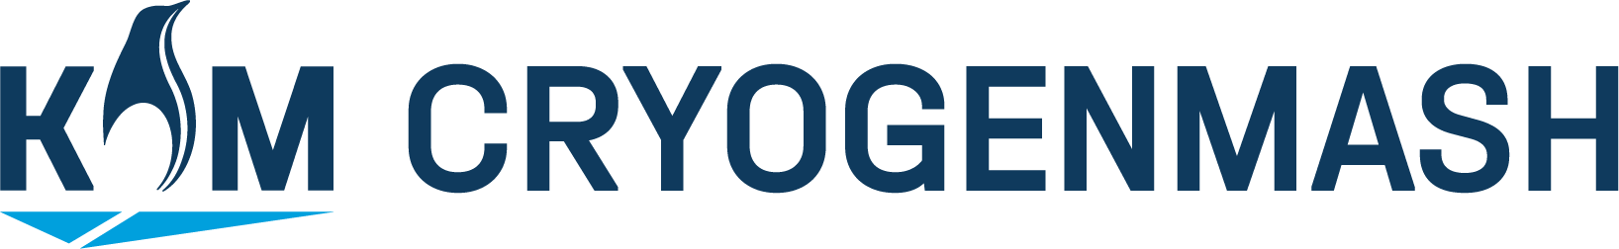

JOINT STOCK COMPANY OF CRYOGENIC ENGINEERING
(JSC “CRYOGENMASH”)
67, Lenin Av., Moscow Reg., Balashikha, 143907, Russia, Tel.: +7 (495) 505-9333. Fax: +7 (495) 521-57-22

Questionnaire for Development of Technical & Commercial Offer for Plant of Hydrocarbons Separation, Including Natural, Associated Petroleum and Factory Gases.

The completed questionnaire should be sent by fax: +7 (495) 521-57-22

Questionnaire for Development of Technical & Commercial Offer for Separation of Hydrocarbons Gases, Including Natural and Associated Petroleum Gases.
1. Initial parameters
- Gas flow rate, Nm³/hr
min
max
mean design
- Gas pressure at plant inlet, MPa (abs.)
at G min
at G max
- Temperature, К, at inlet
- Gas pressure at plant outlet, MPa (abs.)
2. Gas composition
% vol.
-Не
-N₂
-C₁
-C₂
-C₃
-iC₄
-nC₄
-C5+higher
-CO₂
-H₂S
Other

3. Products of separation
- Pressure, MPa (abs.)

- Temperature, К
- Composition, % vol. (or reference to GOST, OST, ТУ)
- Other demands
4. Outside utilities and working fluids
- Electric power
- Water vapor
- Purging nitrogen
5. Climatic and geoseismic conditions at the operation site

6. Indicate below your additional requirements (data) if any

7. Specialist signature and data

CONTACT TELEPHONES:
Sales department | +7 495 505 9333
E-mail: root@cryogenmash.ru Web-server: www.cryogenmash.ru

